# Marketing Analytics- Assignment 5

By Preethi Susan Abraham

1. Analyse the amazon reviews. What products are having a problem?

🡪 Doritos, Pepsi, KFC and the combination of Pepsi-Doritos seem to be having problems. These products seem to be having negative sentiment from customers.

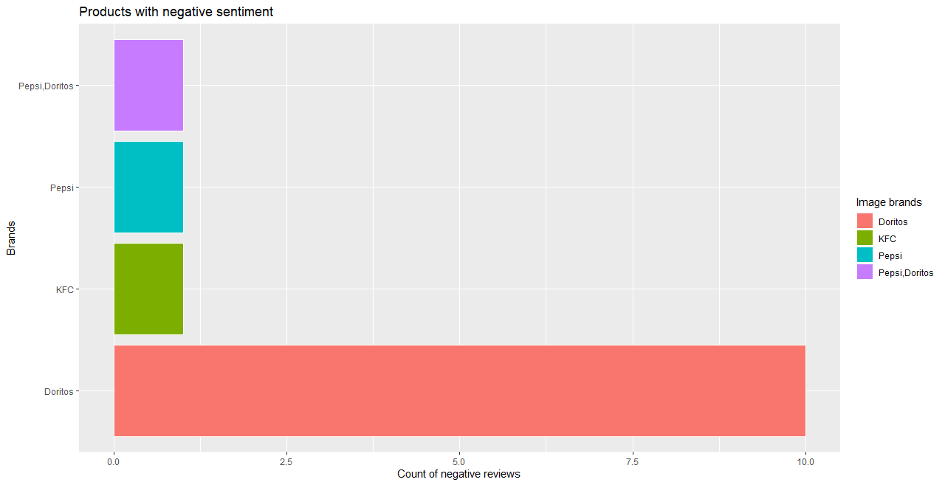

2. For each product that has an increase in negative reviews, what is the reported problem?

🡪 Most of the customers seem to be complaining about how unhealthy the three products (i.e., Doritos, Pepsi, KFC) seem to be. If we observe the common words among content which is classified as “negative sentiment” which are written by customers on online platforms, it can be seen that most of the words are related to “unhealthy foods” (as seen in the figure below).

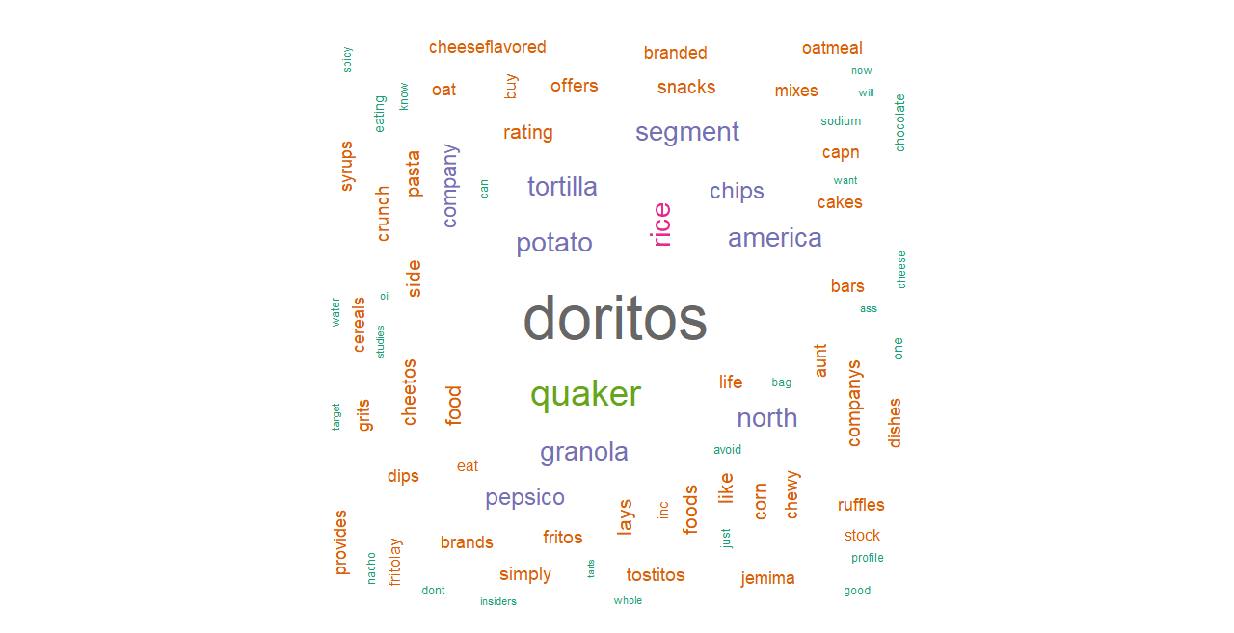

By reading some of the text snippets/tweets from customers, we get a general idea that most of them are mentioning about the unhealthy and addictive nature of Doritos. Some of the text snippets also mention about the stock holdings of PepsiCo Inc. Some of the snippets are shown below:



3. Are the negative reviews increasing everywhere? or are they disproportionally located in one area?

🡪 Most of the negative reviews are from customers from the United States of America. The figure below shows the distribution of negative reviews according to country.

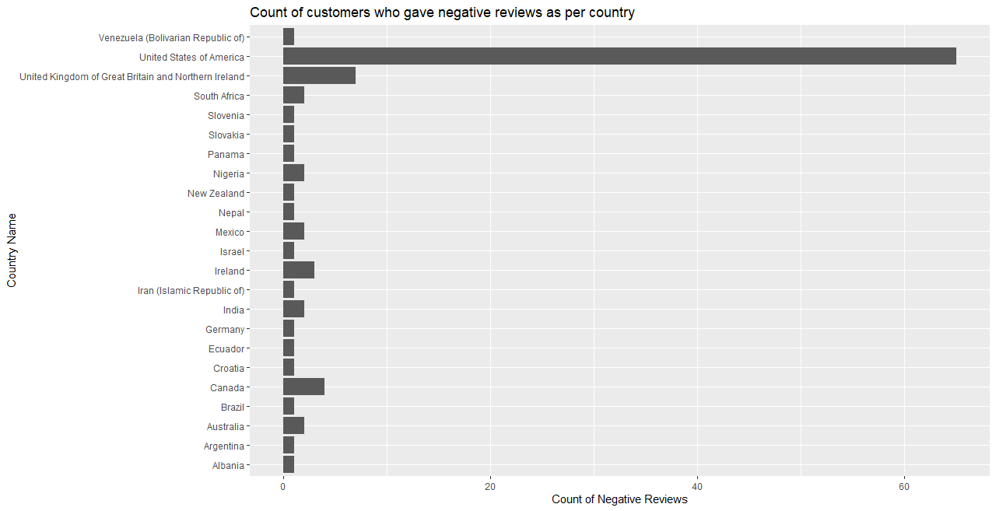

4. Based on the answers above, what recommendations would you make to the client regarding their product?

🡪 The figure below shows the count of positive, negative and neutral sentiment for different products which are being sold by our client. Only a small portion of customers seem to be expressing their opinion about Doritos which are having a negative sentiment. Whereas most customers seem to be expressing a neutral opinion about this product. The graph below also shows that more customers have expressed a positive sentiment towards Doritos in comparison with those who have expressed negative sentiment. Our client should not completely discontinue selling Doritos on their website as this product seems to be gaining the most amount of attention from customers. If we observe words which are associated with the brand “Doritos”, it can be seen that words like ‘excited’, ‘explode in the mouth’, ‘extreme’ etc seem to be used by customers. This shows that even though this brand has a negative sentiment, it would not be wise for our client to stop selling this product. Since Doritos is being labelled as an unhealthy product, our client could instead suggest the manufacturer to introduce a new line of products which could be classified as a “healthy-snacks”.

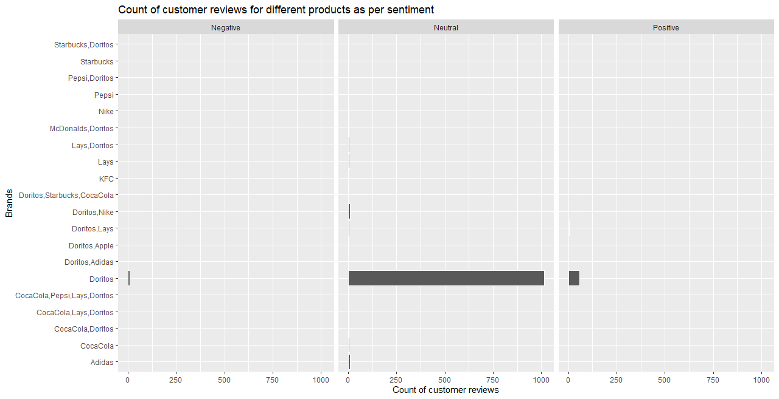

5. Make 3 additional insights from the data that the client could use to develop their product or their marketing

🡪a. If we observe the figure below, it can be seen that most people tend to be using Twitter as a platform to express their views about products. It is surprising to see that most customers generally tend to express neutral opinions. Our client should utilize Twitter as the primary platform to understand their customers and use this platform for marketing their products since it seems to be the most commonly used social media platform among their customers.

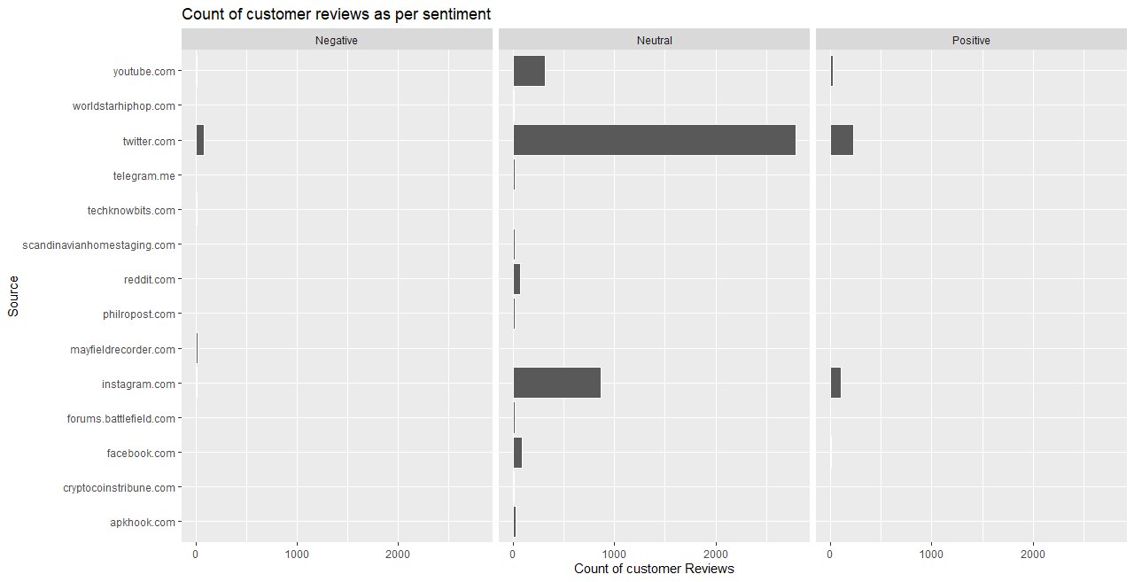

b. Most of our client’s customers are from the US, and they seem to be expressing a neutral opinion about the products sold. Since most customers tend to be expressing neutral sentiment, our client has a lot of scope to improve their marketing strategies to ensure that their customers from US will be happy to purchase their products. Our client should also focus on customers from United Kingdom and South Africa since these countries seem to be a growing market for them.

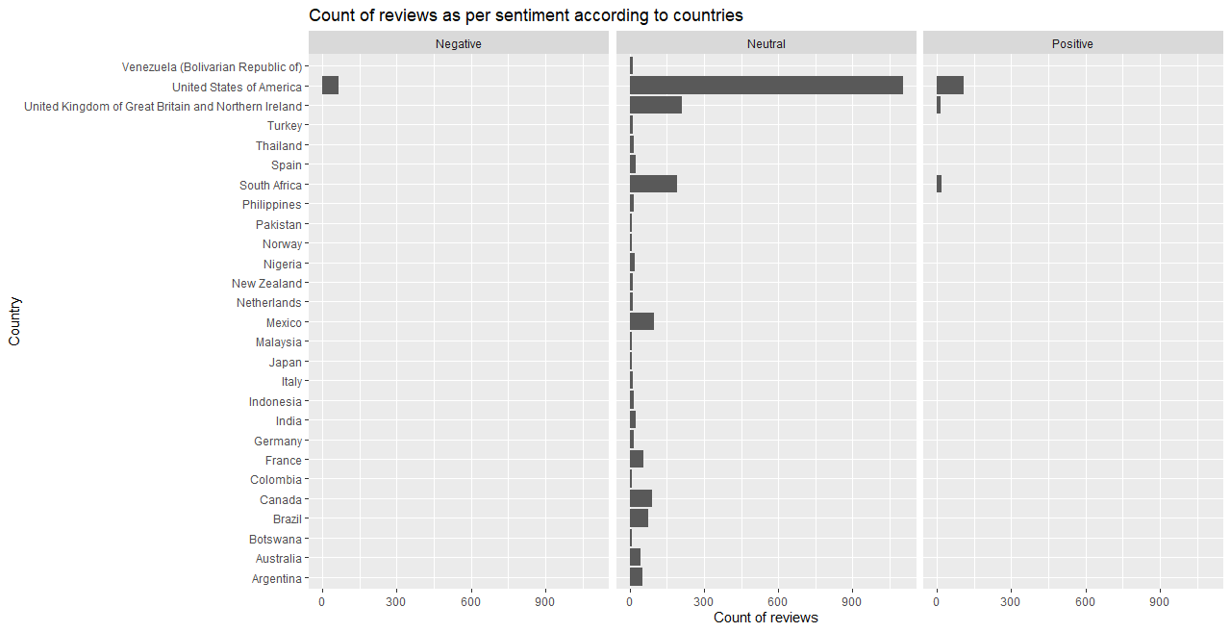

c. By analysing the text-snippets which have negative sentiment, it is surprising to see that inspite of customers expressing emotions like anger, sadness, fear and disgust, they still seem to be trusting the brand. This shows that people will still be willing to purchase Doritos even though they are not happy about the product. Our client does not have to take immediate action to discontinue selling Doritos on their website. Since customers seem to be complaining about how unhealthy Doritos is, our client can focus on launching a snack product by Doritos which could be marketed as “healthier”. Customers already trust the brand, so they may also be willing to buy this new product.

